# Lab: Linear Data Structures

Problems for exercises and homework for the ["Data Structures" course @ SoftUni](https://softuni.bg/courses/data-structures).

You can check your solutions here: <https://judge.softuni.bg/Contests/Compete/Index/550#0>.

## ArrayList<T>

Implement a data structure ArrayList<T> that holds a sequence of elements of generic type T. It should hold a **sequence of items in an array**. The structure should have **capacity** that **grows twice** when it is filled, **always starting at 2**. The list should support the following operations:

* int Count 🡪 returns the number of elements in the structure
* T this[int index] 🡪 the indexer should access the elements by **index** (in range 0 … Count-1) in the reverse order of adding
* void Add(T item) 🡪 adds an element to the sequence (grow twice the underlying array to extend its capacity in case the capacity is full)
* T RemoveAt(int index) 🡪 removes an element by **index** (in range 0 … Count-1) and returns the element

Be sure to **test implemented operations** whenever possible before moving to the next

### Examples

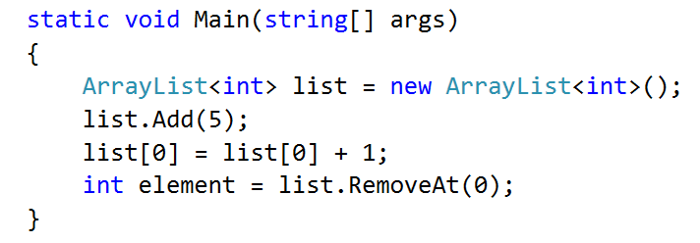

### Solution

Declare the class ArrayList<T>

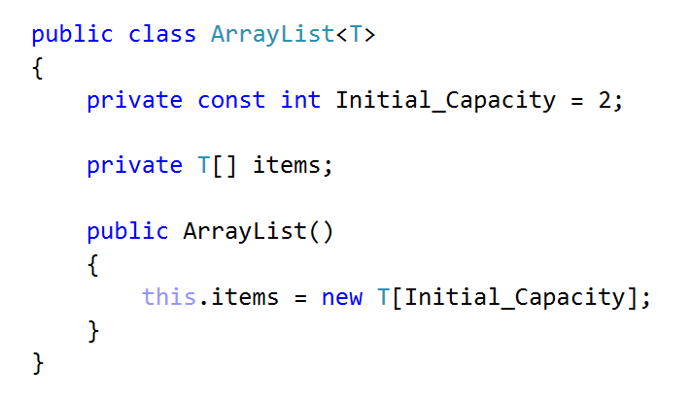

Start with Count and Indexer

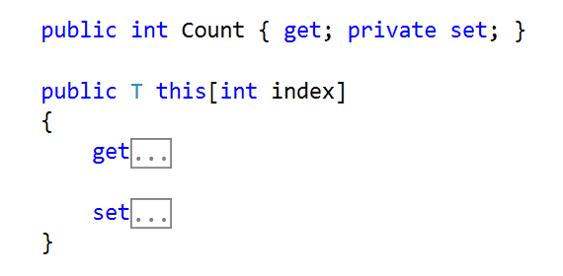

Implement get by index

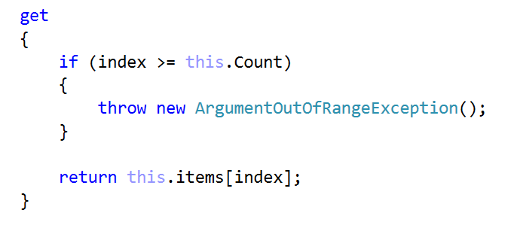

And set by index should be

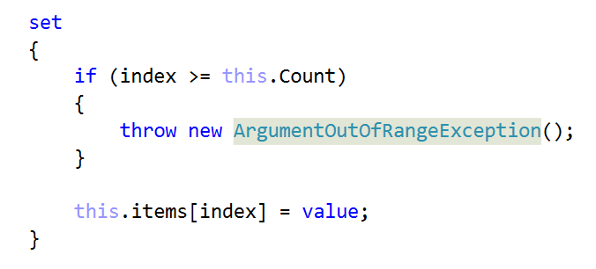

Implement Add and Resize methods

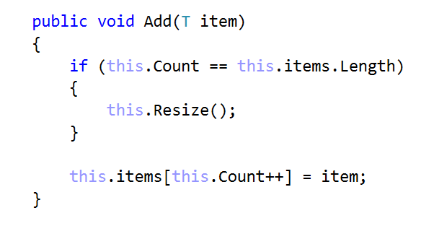

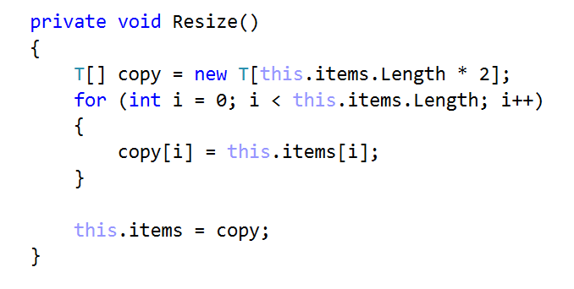

Finally, implement RemoveAt, Shrink and Shift methods

